**Q: 10**

**Grid**

**Time to solve the problem**

**10 minutes**

**Level 0**

**Topics**

**Grid**

**Problem Statement**

**Create the below layout. 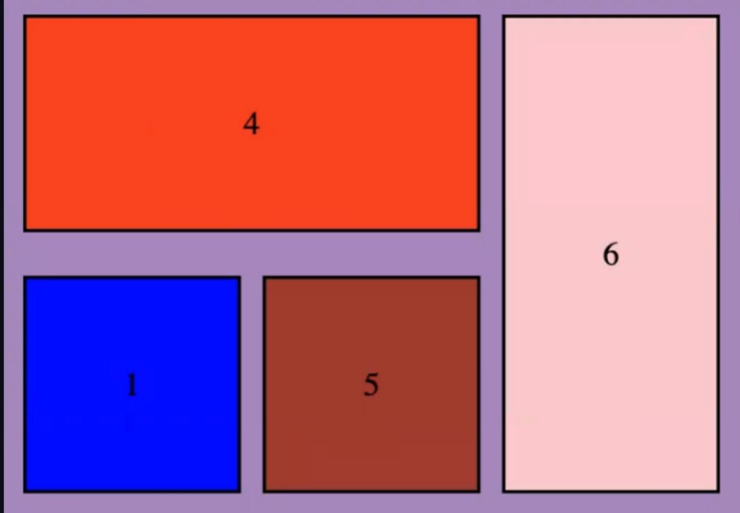**

**Submission Guidelines**

**Submit GitHub link**